**Binayak Bishnu**

**20BIT0155**

**LAB CAT**

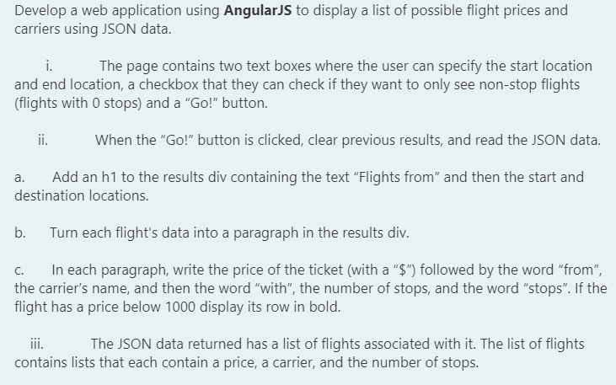

<!DOCTYPE html>

<html lang="en">

<script src="https://ajax.googleapis.com/ajax/libs/angularjs/1.8.0/angular.min.js"></script>

<script src="https://ajax.googleapis.com/ajax/libs/jquery/3.5.1/jquery.min.js"></script>

<head>

<meta charset="UTF-8">

<meta http-equiv="X-UA-Compatible" content="IE=edge">

<meta name="viewport" content="width=device-width, initial-scale=1.0">

<title>20BIT0155</title>

</head>

<body>

<div ng-app="myApp" ng-controller="jsCtrl">

<label>Start location: <input type="text" id="start" ng-model="start"/></label>

<label>End location: <input type="text" id="dest" ng-model="end"/></label>

<label>Non-stop? <input type="checkbox" id="stops"></label>

<button id="go" ng-click="fetch()">Go!</button>

<div id="results" ng-hide="myvar">

<h1>Flights from: {{start}} {{end}}</h1>

<p id='data'>

</p>

</div>

</div>

<script>

var app = angular.module('myApp', []);

app.controller('jsCtrl', function ($scope) {

$scope.myvar = true;

$scope.fdata={

"Edinburgh":{

"start":"Seattle",

"flights":[{"carrier":"Delta","price":812,"stops":2},

{"carrier":"Air France","price":1020,"stops":0},

{"carrier":"Air France","price":1190,"stops":3}]

},

"New York":{

"start":"Seattle",

"flights":[{"carrier":"British Airlines","price":782,"stops":1},

{"carrier":"Delta","price":1562,"stops":2},

{"carrier":"United","price":957,"stops":1},

{"carrier":"KLM","price":687,"stops":3},

{"carrier":"KLM","price":1458,"stops":1}]

}

}

$scope.fetch= function () {

$scope.myvar = false;

var en= $scope.fdata[$scope.end];

if($scope.start==en.start){

var d="";

for(var i=0;i<en.flights.length;i++)

{

d=d+"Price:$"+en.flights[i].price+"<br>"+"from"+en.flights[i].carrier

+"<br>"+"with "+en.flights[i].stops+" stop";

}

document.getElementById("data").innerHTML=d;

}

}

});

</script>

</body>

</html>

